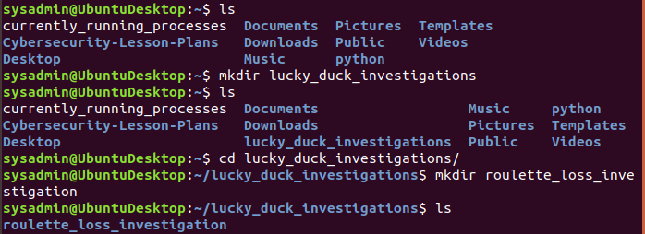

We begin with our initial setup steps by first creating the “lucky_duck_investigations” directory. Within that, we then make “roulette_loss_investigation” directory

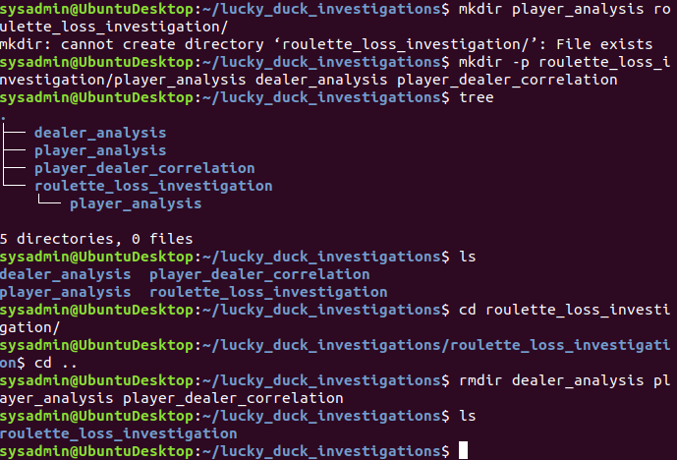

We then try to make the subsequent directories of “dealer_analysis” “player_analysis” and “player_dealer_correlation” under the “roulette_loss_investigation” directory, but all in one command. The command did not work as I wanted and created directories outside of the desired directory, due to syntax error. I then use “rmdir” to remove the created directories.

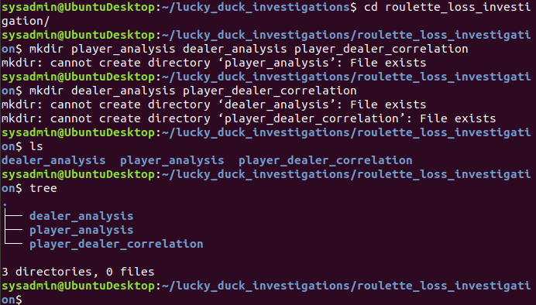

As I try to make the new directories, I discover that the directories already exist, most likely as a result of my previous “mkdir -p” command. Now all files are in place, all that remains is to create note files for each directory.

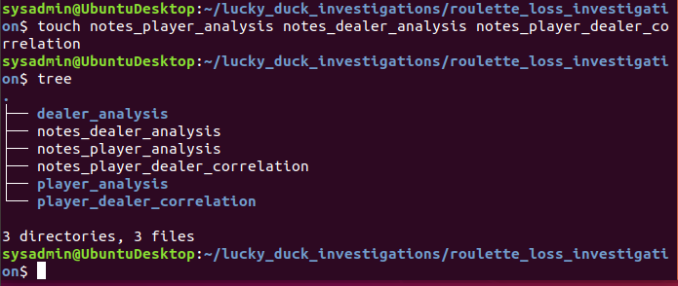

We are now all set up to begin the assignment.

**Step 2: Gathering Evidence**

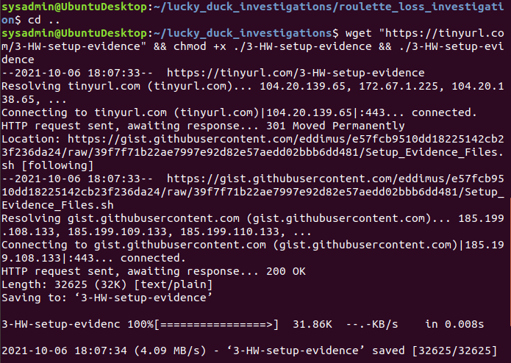

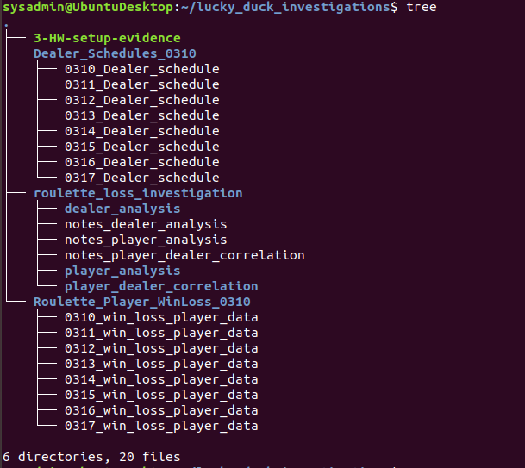

We run our wget "https://tinyurl.com/3-HW-setup-evidence" && chmod +x ./3-HW-setup-evidence && ./3-HW-setup-evidence command and then “tree” within the “lucky_duck_unvestigations” directory to confirm the correct execution of the command. We now have all the necessary files to start our analysis.

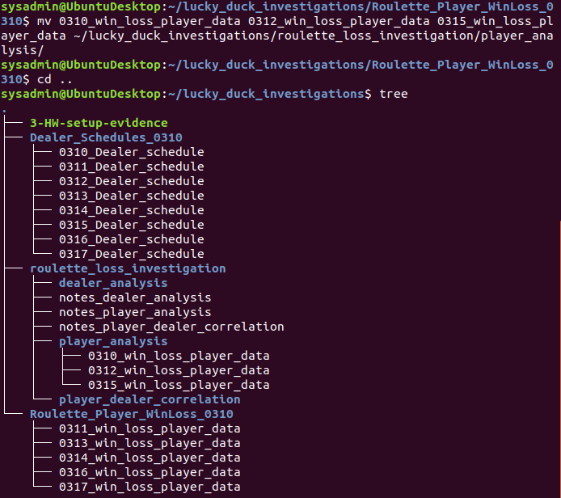

The next step is to move the relevant files of dates March 10, 12, and 15th to “player_analysis” (shown above) and the relevant schedules to “dealer_analysis”. (Shown below)

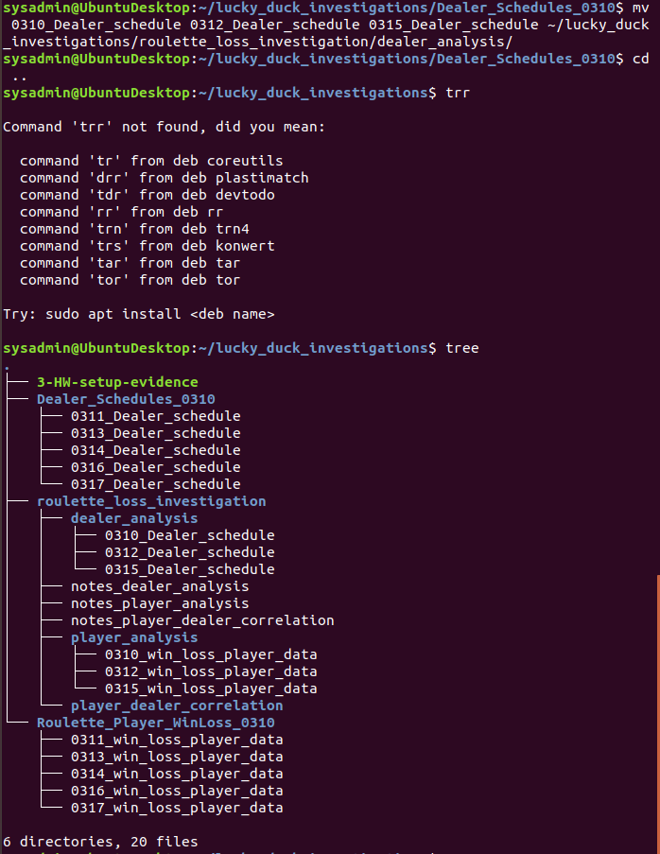

**Step 3: Correlating the Evidence**

We now need to find and isolate losses which are indicated with a negative number as listed by step 3 notes.

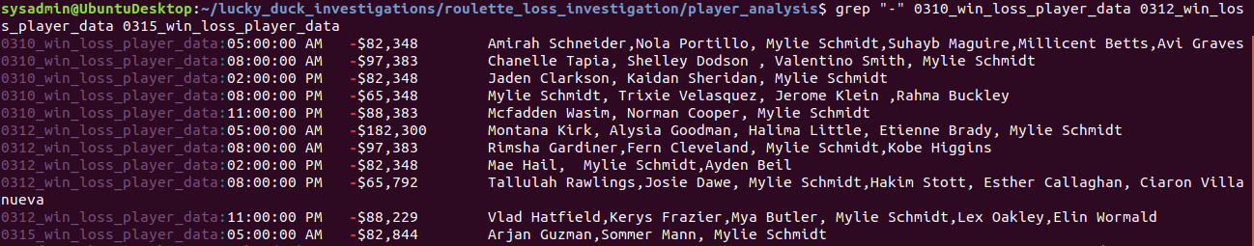

The picture is a bit smaller this time, but sufficient to find the information of all the losses. We now need to turn this into a “roulette_losses” file.

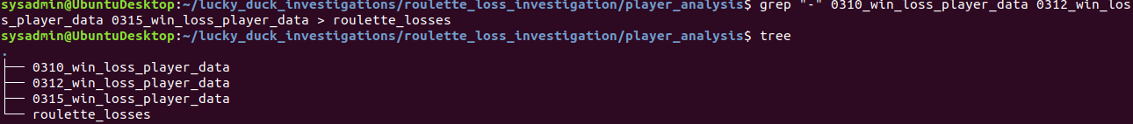

There’s the file in the “player_analysis” directory. Now to check the contents to make sure the command was successful. We can do this with a tail command.

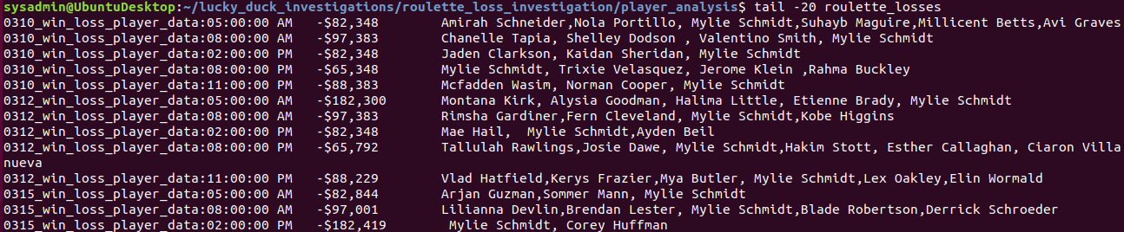

There’s all our data now, ready for analysis. The times the losses have occurred are displayed with the tail command above. But now we need to find a certain player active during those times and how many times they played. A cursory glance of our tail result shows a “Mylie Schmidt” at least twice so we can start there to see if they played at every time there was a loss. For this we will run a grep command for “Mylie”.

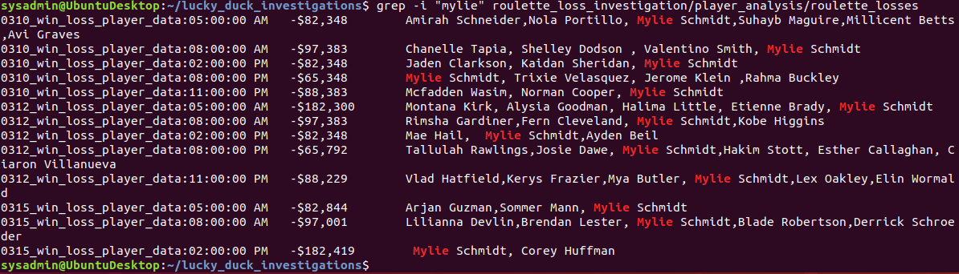

Looks like Mylie shows up frequently. Let’s find out how many times using a word count command since it’s faster than counting.



Looks like Mylie has played a total of 13 times across each time period the losses occurred. We have our data. Now to place it all in the “notes_player_analysis” file we created earlier. So we’re going to run the following:



We ran grep the first time to get all the time and player data. Then we run grep again with a “-c” option to get the “Mylie” count of 13 added to the file as well. We add it to the file to avoid overwriting the file. Now to just double check the file we will run a “tail” command.

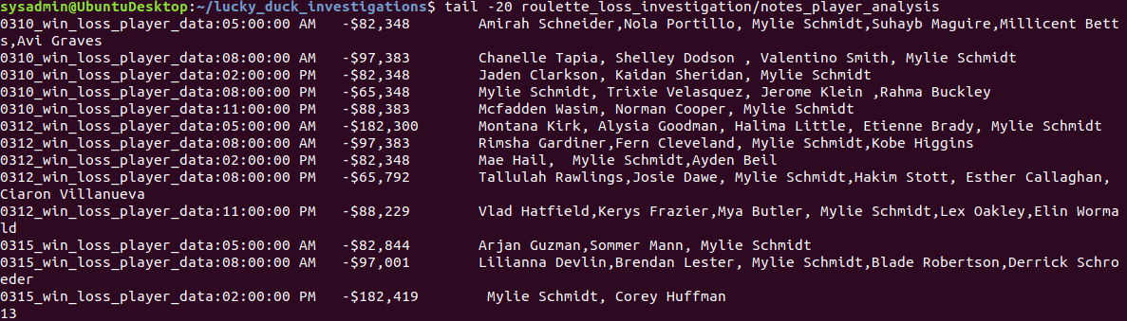

There’s all the information with “13” in the last row. Now we move to examining the Dealer data.

**Part 2 of Step 3:**

Let’s take a quick look at the Dealer data we have available to us for each “Dealer_schedule”.

The data will be listed in order starting with March 10th, then 12th, then 15th.

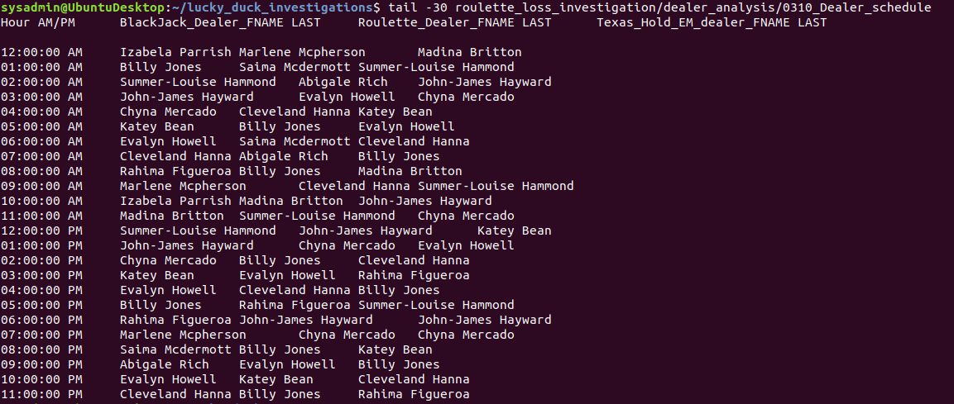

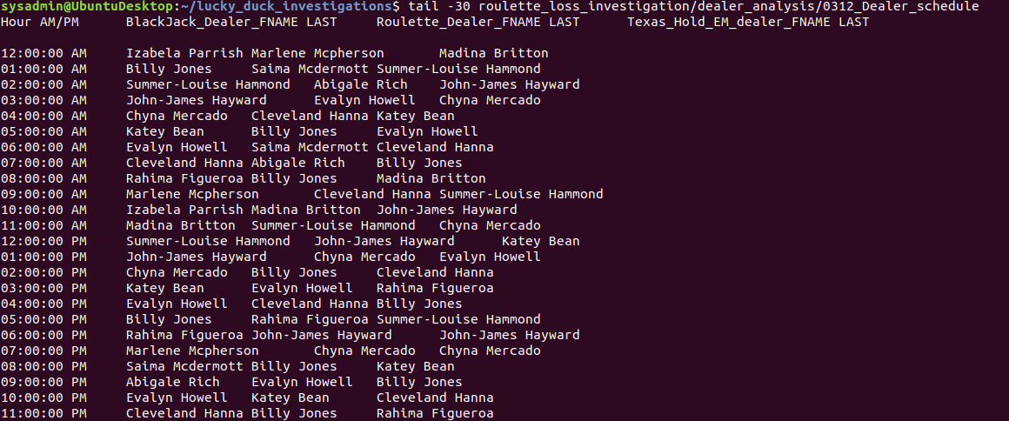

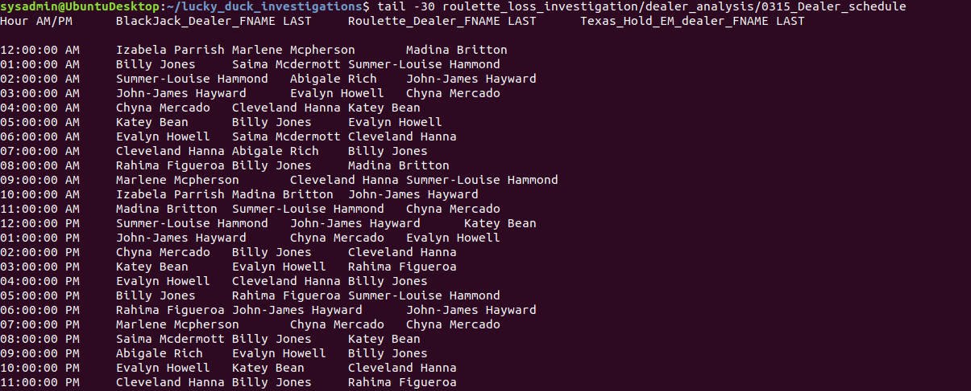

Now we need to craft some scripts that will pull our relevant information of Time, AM/PM, First name, and Last name of the Dealers working the days of the losses. We will do this with separate scripts. For this, we will run the vim command.

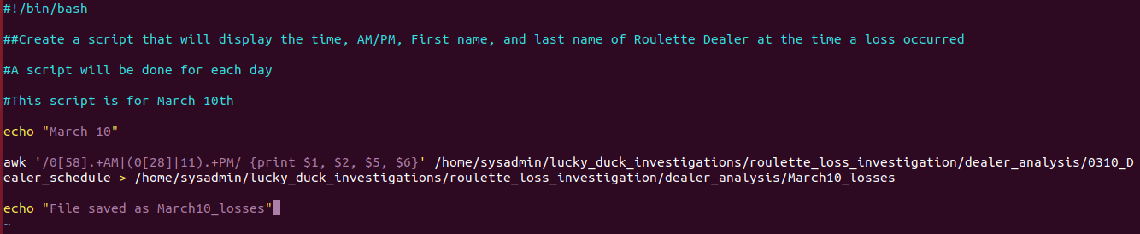

Here is the first script for March 10th. Now to test it.

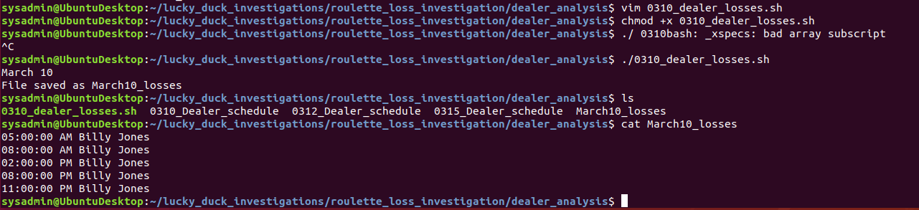

Vim 0310_dealer_losses.sh is our first vim script. We run chmod +x of the script to make it executable. We then run the script to give us the necessary information as part of analysis for March 10th. We cat the March10_loses to check the resulting information and we see Billy Jones is there for all the times. Now for the other two scripts.

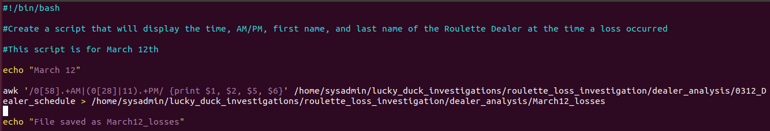

There’s the second script for March 12, same as the first.

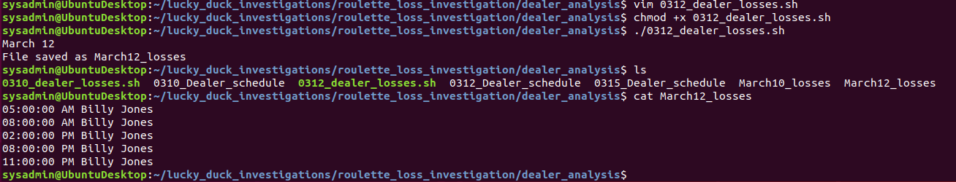

So here are the commands and results for the rest of script 2. As you can see, it executed successfully and running cat on the resulting March12_losses gives us Billy Jones once again. We have 10 out of our 13 losses. The last script will give us the remaining 3.

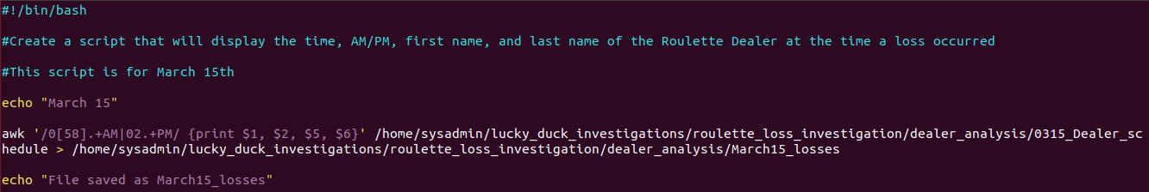

Here is the third script with slight modifications to reflect the change in data noted on March

15th’s dealer schedule.

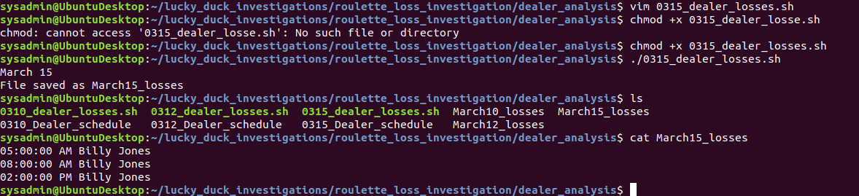

There are the commands for the final script, showing us the last 3 time stamps of our total 13 evidence of losses that have occurred. Now we’re going to cat all the March losses into a file called “dealers_working_during_losses”

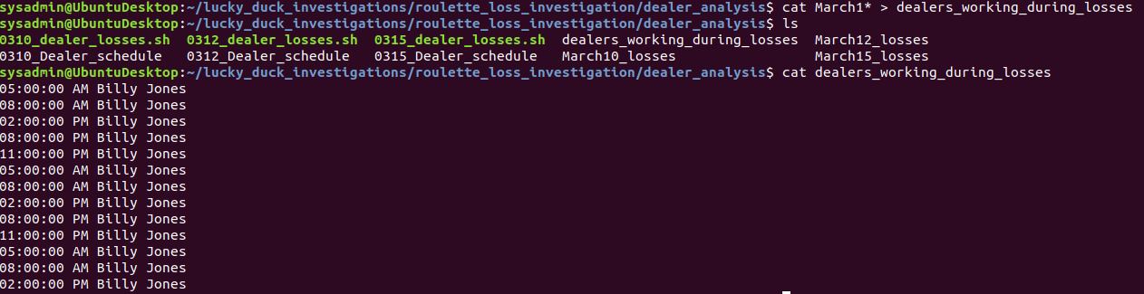

All 13 incidences of loss have been recorded in the singular dealers_working_during_losses. The separate “March1*_losses” files have been left to keep the information organized via date. We now write notes in “notes_dealer_analysis”.

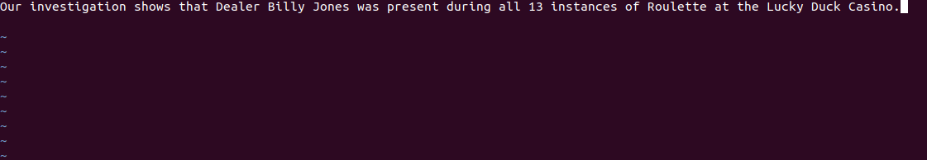

We also fill in our deductions from the resulting data in “notes_player_dealer_correlation”

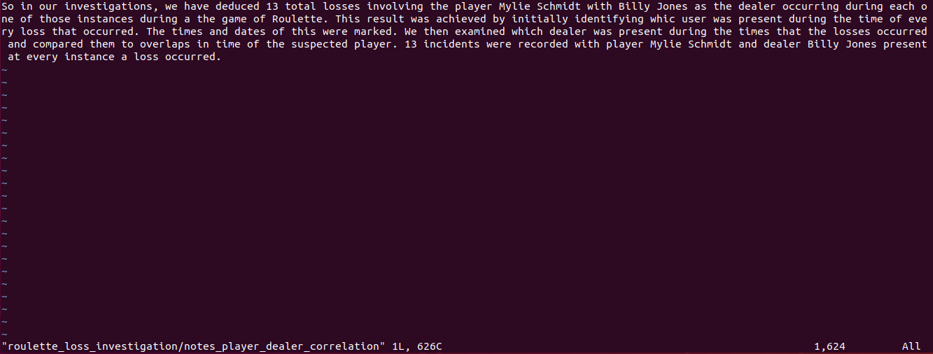

Step 4: Scripting Your Tasks

We now need to put together a script that will analyze the overall employee schedule so that we can find the date, time, and what specific employee is working during that time frame.

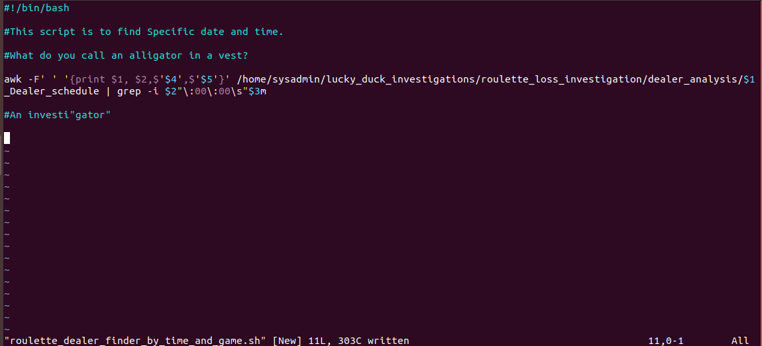

Here is our script. Below, we went ahead and tested the script before making it executable. We then executed the script in the current working directory with a different set of inputs to show that it can find any dealer with the related information.

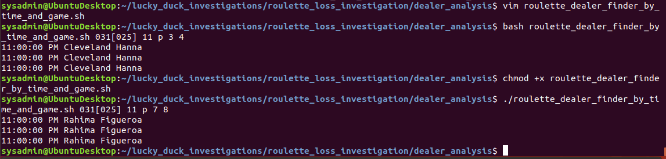

That about wraps up all of our sleuthing for the Lucky Duck Casino case. Now we copy everything over to “player_dealer_correlation”





A quick look at the folder tells us everything is in place. And that concludes the assignment. Happy Hunting!